**OPIM 5671**

**Data Mining and Business Intelligence**

**Project 2**

DisneyLand Reviews



University of Connecticut

Spring Semester, 2023

Team 2

***Submitted by***

**Vaishnavi Mamillapalli**

**Shiwen Shen**

**Krithika Gaikwad**

**Sumit More**

**Rohit Ghosh**

**Table of Contents:**

| 1. **Executive Summary** | **3** |
| --- | --- |
| 1. **Data Source** | **4** |
| 1. **Data Description** | **4** |
| 1. **Word Cloud: California** | **5** |
| 1. **Word Cloud: Paris** | **5** |
| 1. **Word Cloud: Hong Kong** | **5** |
| 1. **Process Flow: Disneyland- California** | **6** |
| **a. Data Partitioning** | **7** |
| **b. Text Parsing** | **8** |
| **c. Text Filtering** | **11** |
| **d. Text Clustering** | **12** |
| **e. Text Topic** | **12** |
| 1. **Process Flow: Disneyland- Paris** | **24** |
| **a. Data Partitioning** | **25** |
| **b. Text Parsing** | **25** |
| **c. Text Filtering** | **26** |
| **d. Text Clustering** | **26** |
| **e. Text Topic** | **27** |
| 1. **Process Flow: Disneyland- Hong Kong** | **37** |
| **a. Data Partitioning** | **38** |
| **b. Text Parsing** | **38** |
| **c. Text Filtering** | **38** |
| **d. Text Clustering** | **38** |
| **e. Text Topic** | **39** |
| 1. **Models** | **41** |
| 1. **Conclusion** | **43** |
| 1. **Recommendations** | **43** |
| 1. **References** | **44** |

1. **Executive Summary:**

The Disneyland Reviews Data Mining Project analyzed a large number of reviews of the Disneyland theme park for 3 locations namely California, Hong Kong and Paris to understand what people think about Disneyland. The project found that most people who visit Disneyland like it a lot and are happy while they are there. The rides and shows are very popular, but sometimes it can be very crowded and visitors have to wait in long lines. The food and drinks at Disneyland can be good, but some people think they are too expensive and not very tasty. The people who work at Disneyland are usually friendly and helpful, and keep the park clean. These findings can help Disneyland improve their operations and make the park a better experience for visitors.

1. **Data Source:**

We have got this dataset from the Kaggle website. Below is the link for the same:

<https://www.kaggle.com/datasets/arushchillar/disneyland-reviews>

1. **Data Description:**

The dataset includes 42,000 reviews of 3 Disneyland branches - Paris, California, and Hong Kong, posted by visitors on Trip Advisor.

The dataset has 6 columns:  
1. Review_ID: unique id given to each review

2. Rating: ranging from 1 (unsatisfied) to 5 (satisfied)

3. Year_Month: when the reviewer visited the theme park

4. Reviewer_Location: country of origin of visitor

5. Review_Text: comments made by visitor

6. Disneyland_Branch: location of Disneyland Park

7. New_Rating: We have classified the ‘Rating’ into two categories. The ratings 1-4 are classified as ‘0’ and rating 5 is classified as ‘1’.

We have separated the data into three available locations based on Disneyland Branch.

1. **Word Cloud for DisneyLand California:**

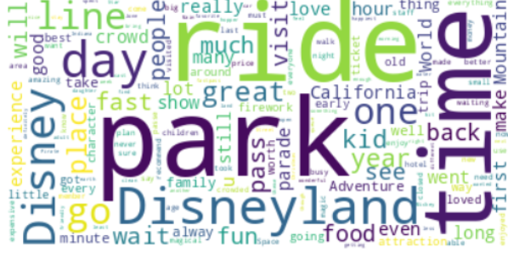

1. **Word Cloud for Disneyland Paris:**

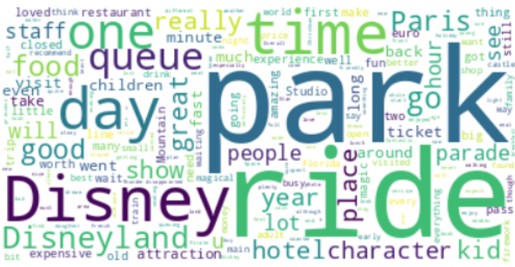

1. **Word Cloud for Disneyland Hong Kong:**

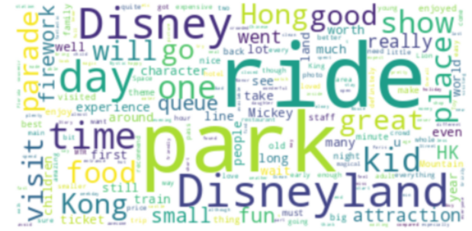

From the above word cloud from all the locations, we can see that the words ‘Disney’, ‘ride’, ‘park’ have high frequency and we have filtered out those words.

1. **Process Flow- Location: Disneyland California:**

The final model that the team came up with,

Diagram:

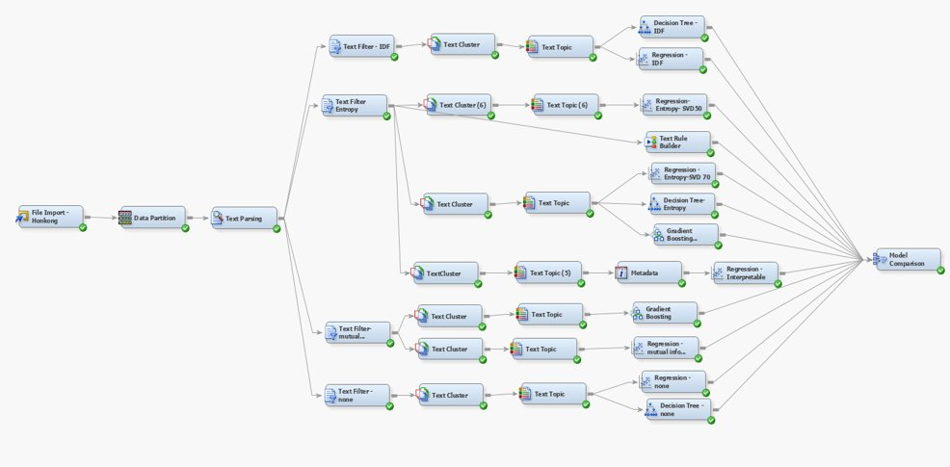

**File Import:**

Our target variable is New_Rating. The first model we created is the Disneyland California.

Since the data is available in single csv file, it is imported in SAS® Enterprise Miner™ using the file import node. The import file points to the folder that contains the reviews in CSV documents, with all the reviews in one document.

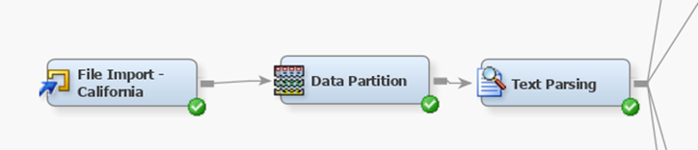

Figure 2 Model for import node

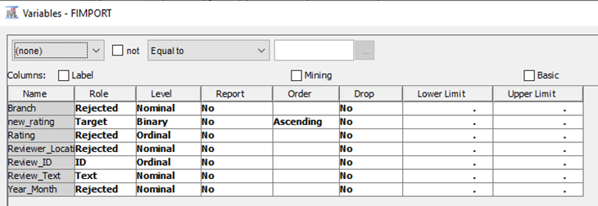

Figure 3 Variable table

**4a. Data partitioning:**

In order to evaluate our model’s accuracy and accountability, we use the data partition node to divide the data into 3 sets.

In the first time, we tried the data set of training with 50%, Validation as 30%, Test as 20%. And then we got the high accuracy of the model with 0.89. After the meeting with Professor, he suggested us to change the partition having more training data to increase the accountability with the mode. So we set the 60,20,20 as the following table shows,

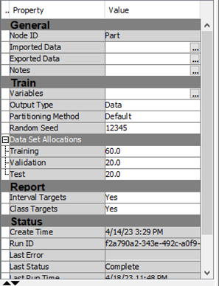.

Figure 4 Property of Data partition node

**4b. Text parsing:**

For the purpose of extracting the relevant information from the unstructured dataset, we used the text parsing node to analyze that.

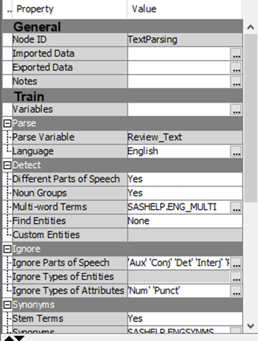

Property of Text parsing

The number of documents by Frequency scatter plot displays the number of documents in which a term appears versus the frequency of occurrence of that term in the entire document collection.

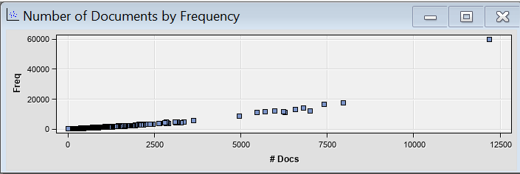

The text parsing node also generates the term by frequency document matrix which is used to understand the most frequently occurring term and the number of documents it has occurred in. It is also used to analyze the terms that are rarely used. Ideally the terms that are used moderately are the ones that are the most helpful in exploration and modeling.

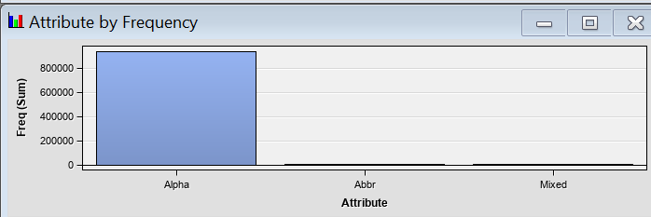

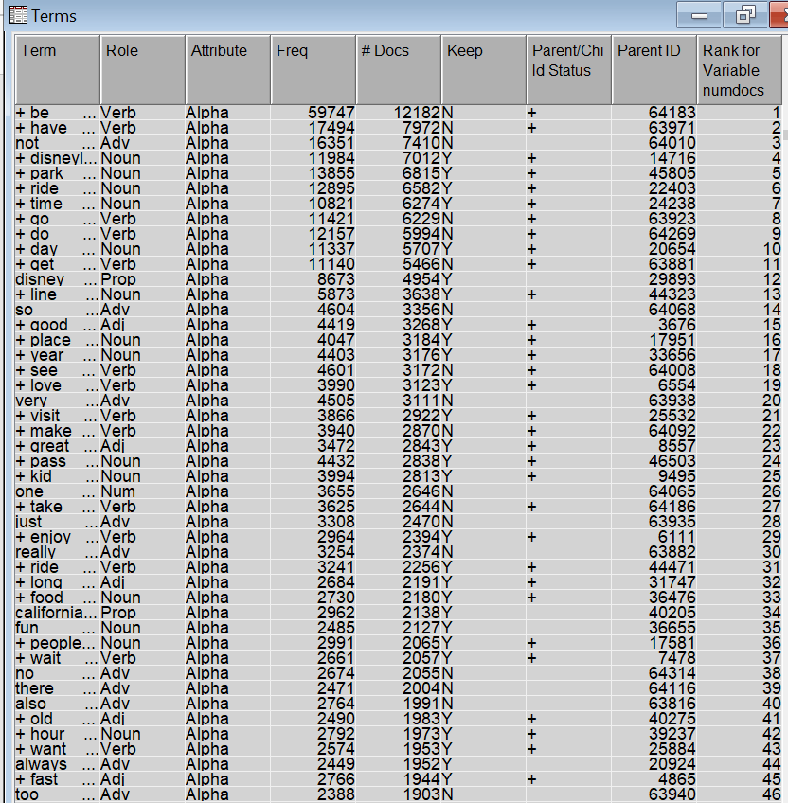

Output of Text Parsing

The most frequently used terms are time, day, good,place, love, enjoy, kid which makes sense since the reviews are for a theme park. Some of the terms which are misspelt are eliminated later using the text filter node.

We just used the default stop list to remove terms which are unimportant or irrelevant for text analysis.

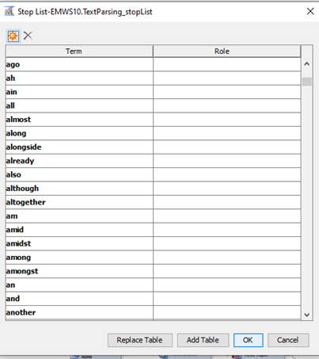

Figure 6 Stop list

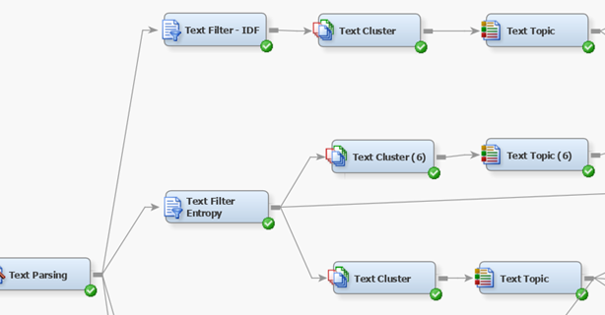

Figure 7 Model Preparation

This is the preparation for the modeling.

**4b. Text Filter node:**

The text filter node is added to the text parsing node and is used to eliminate the terms that occur the least number of times in all the documents by manually entering the minimum number of documents it should be present in the properties panel. We can also perform spell check by enabling the option again in the properties panel. Spell check would also suggest the terms that could be potential synonyms. The term ‘betters’ ‘bests’, better, bettered are grouped into one term ‘good’ and so on.

In order to find which model fits the best, we used the frequency weighting as log and different term weight to preprocess the dataset, like Entropy, Inverse Document Frequency, Mutual Information and None. And the Mutual Information should be used for the binary target variable, we met with the requirement.

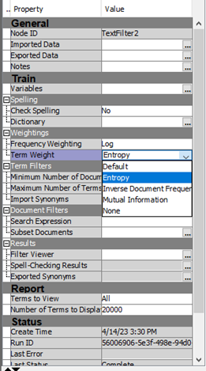

Figure 8 Property of Text filter node

The result of ZIPF plot were satisfactory with extreme high and low frequency terms identified as could be seen from the following chart from IDF filter result and table.

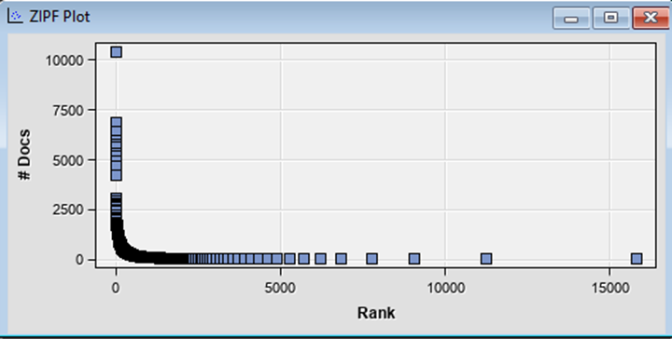

Zipf Plot

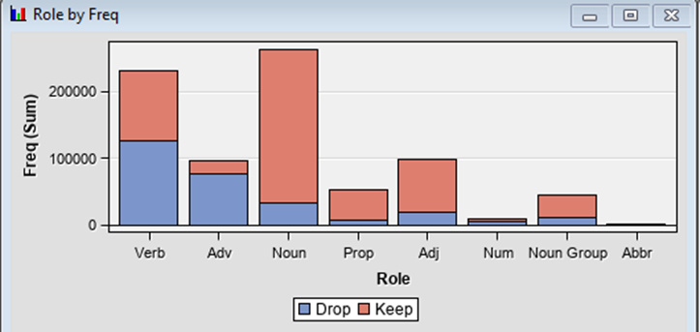

Term Role by frequency

**4c. Text Clustering and Text Topic:**

We used different combinations with SVD Resolution, SVD Dimensions and the number of Clusters to decrease the dimensionality and the complexity of the data. It can help improve the efficiency and accuracy of the analysis and make it easier to identify meaningful insights and trends in the text data. We would finally get 40 clusters because we selected the exact number for that.

Here is the output for Text Cluster node with Entropy-log-SVD70 which we used for Metadata. 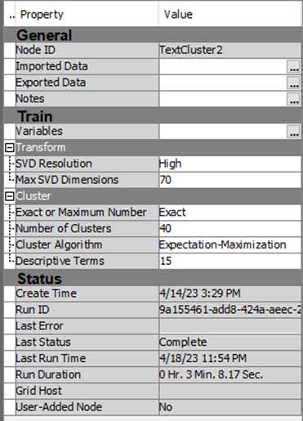

Figure 11 Property of Text Cluster node

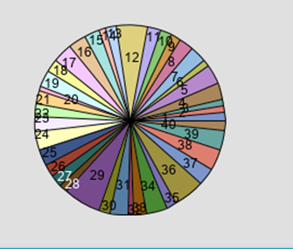

Figure 12 Text Cluster Frequencies

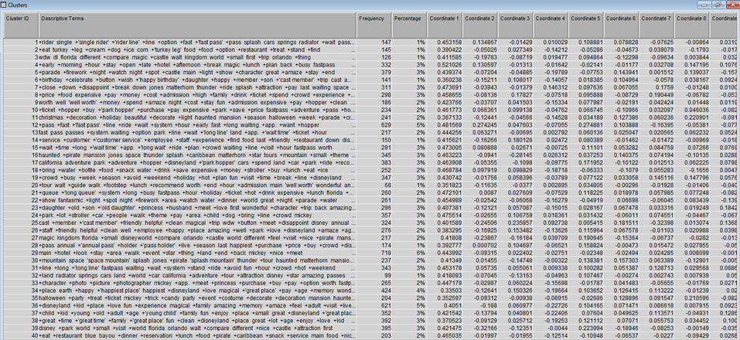

Figure 13 Specific Clusters

For the text topic, we made it as 25 topics. One document can only be included in 1 document, but one document can belong to many topics.

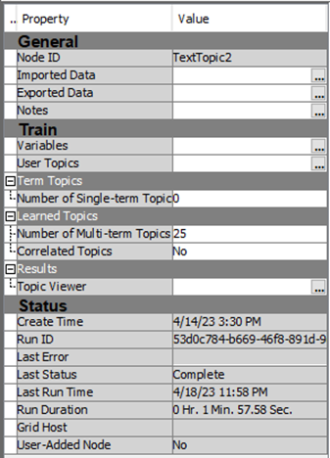

Figure 14 Property of Text Topic node

Here is the output for text topic Entropy-log-SVD70 which we used for Metadata.

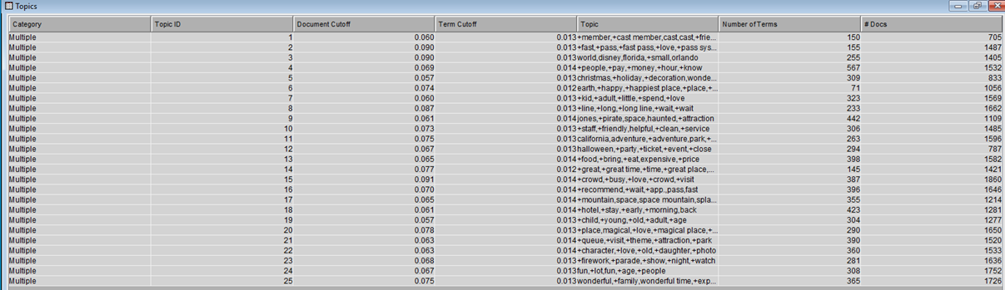

Figure 15 Specific Text Topic

Metadata Node:

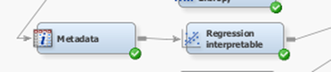

Figure 16 Model for Metadata

Here we rejected the Text Cluster_SVD and Text Topic_raw and input the Text Cluster_prob and Text Topic as the new role to prepare for the following analysis.

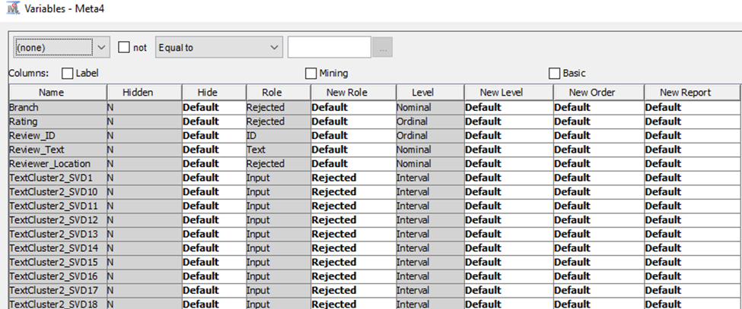

Figure 17 Interpretable (1)

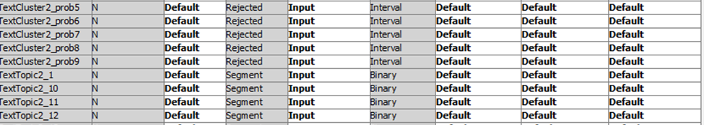

Figure 18 Interpretable (2)

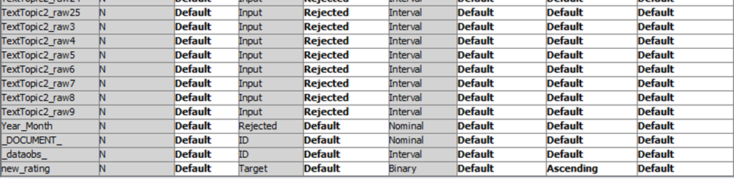

Figure 19 Interpretable (3)

**Model Comparison:**

Finally, we combined all the model we created to compare the ROC and Misclassification to get which model performs the best. There are 12 models as we showed following.

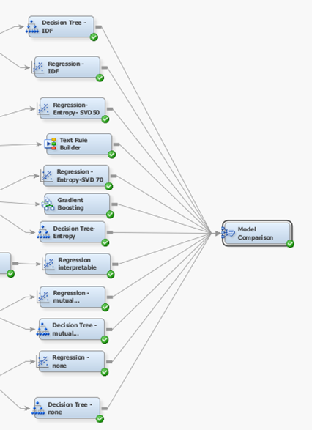

Figure 20 Model for model comparison

In the property of Model Comparison Node, we used the Statistics as ROC and the text dataset.

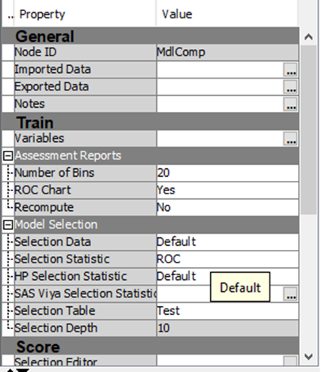

Figure 21 Property for Model Comparison node

Here Is the output for different models. We could find that the Regression with Entropy of high SVD 70 is the beat model of .804. With the overview of the table, we also find that the regression model always performs well then the decision tree model.

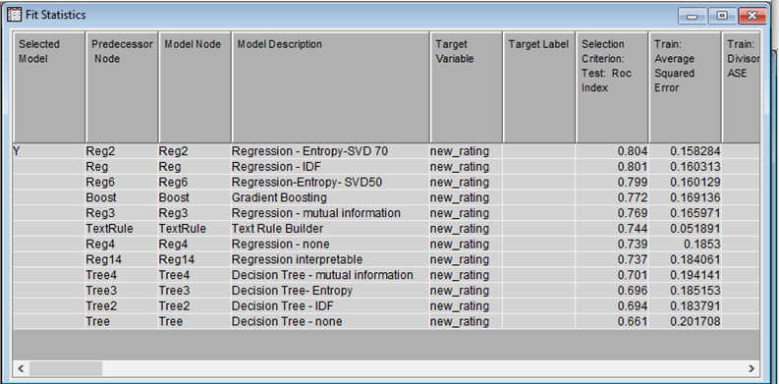

Figure 22 Statistics for Models

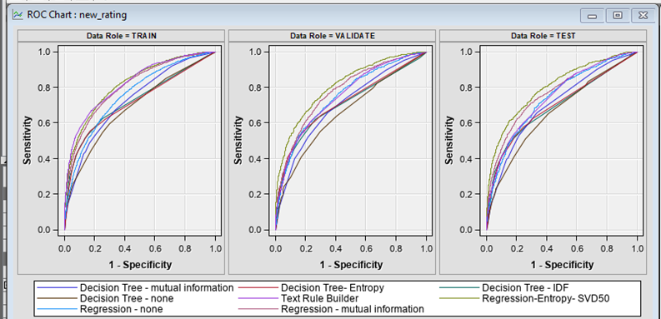

Figure 23 ROC graph for models

**Model analysis**

In our early exploration, we realized that logistic regression models with Entropy had one of the highest ROC. Thus, we focused using METADATA for Entropy weight for original dataset. We analyzed the ‘maximum likelihood’ in details to get more meaning business insights.

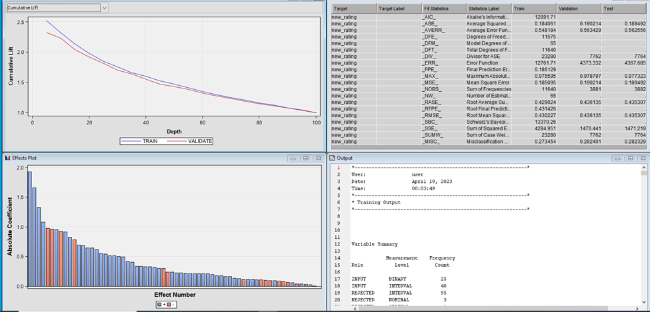

Figure 24 Model analysis

Here is the Regression Entropy interpretable for original dataset.

We can make some analytics on the model we run and metadate we created, for example, differentiate the attitude, like positive and negative one.

If the estimate is greater than 0, it represents the positive attitude. Inversely, if the estimate is less than 0, it represents the negative attitude. So, we could compare the value of estimate to see which cluster or topic showed the significant and strong feelings for the Disneyland California.

For the Text Cluster, we could see the customers’ negative attitude from cluster 7,8,13​. They could be disappointed with the long line. And they thought the Food/drink and ticket are so expensive. Even use the fast pass, they still needed waiting in long line. In the same way, we could find the positive attitude from cluster 6,26,36. For example, people might feel the happiest person to have the birthday in Disneyland California. They thought the Staff are help and the park is very clean.

For the Text topic, we used the same method to analyze. We could know tourists’ negative attitude from topic 3,4,8, like they thought the Disneyland California is smaller than Florida. And they paid a lot and spent time on long wait. The positive attitude based on topic 5,6,24 showed their preference during holiday like the Christmas. Disneyland California is really the happiest place on the earth.

​ 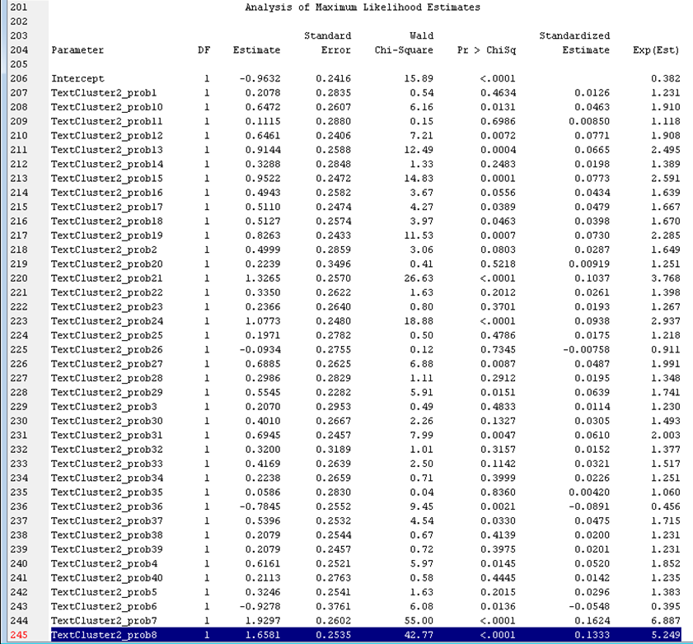

Figure 25 Analysis of Maximum likelihood Estimates (1)

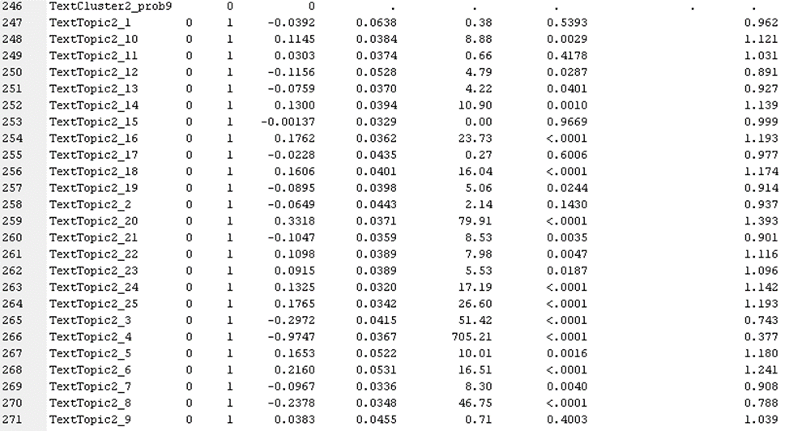

Figure 26 Analysis of Maximum likelihood Estimates (2)

In this way, we can predict their attitude as well as the rough rating if those terms are included in the reviews.​

**Concept Links**

Furthermore, we checked 2 words with high frequency for concept linking. The first one is ‘Time’, which was mentioned 9117 times and the term ‘food’, which was present for more than 1823 documents. We could the high association with ‘time’ and ‘wait time’, ‘Hopper’, ‘move’.

The ‘food’ was highly associated with ‘water’, ‘great food’ and ‘restaurant’.

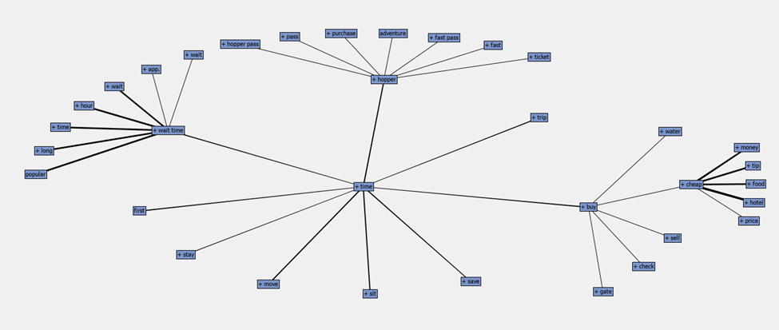

Figure 27 Concept Link (1)

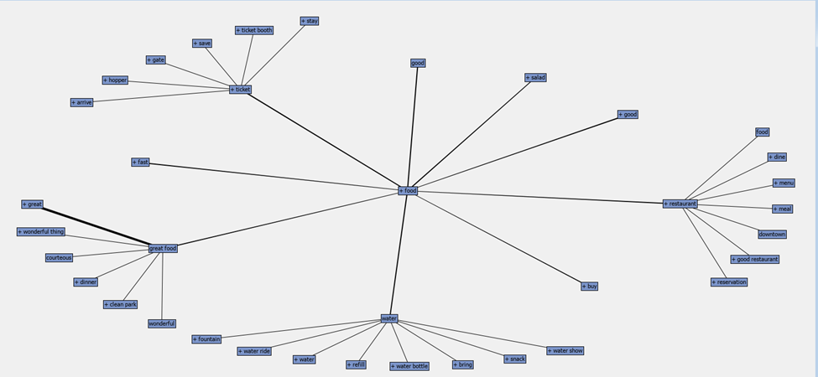

Figure 28 Concept link (2)

1. **Process Flow: Disneyland- Paris:**

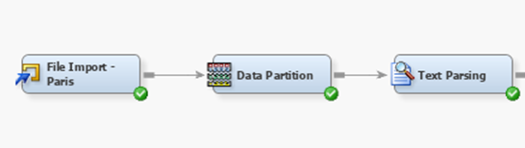

Figure 1 ‑1 Importing Disneyland Paris file, data partition, and Text Parsing

The Excel file for Disneyland Paris contains data about the reviews of Paris. As shown in Figure 2-1 from the file import node, the path for the file is given and hence the file is imported.

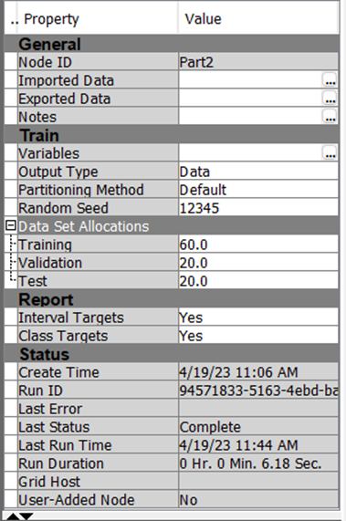

Figure 1‑2 Data partition properties panel

The Data is partitioned for training, validation, and Testing, in the ratio of 60:20:20.

For the text Parsing node, the default stop list is used, and the minimum number of document value set to 4, so that the terms that appear in less than 4 documents are ignored.

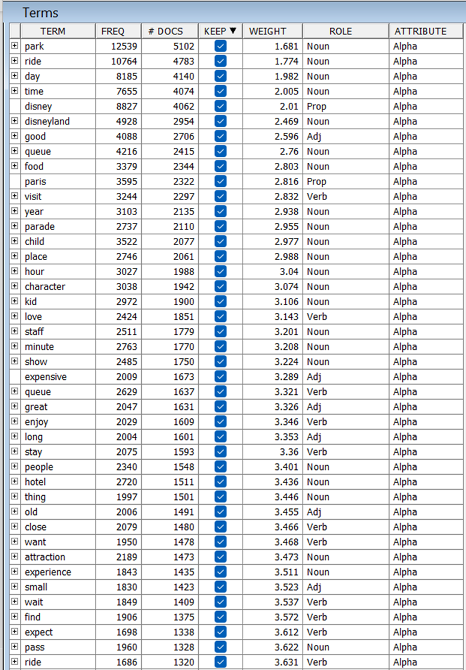

Figure 1‑3 Filter Viewer

The above figure shows the Filter Viewer in the text filter node in which, we rejected all the terms that appear in less than 4 documents.

**Text Filter:**

After Text parsing, we connected 4 Text Filter nodes, and in the Text filter node, we used the default frequency weight which is Log, and Term weight we set term weight as IDF, Mutual Info, Entropy, and None for respective filter nodes and then applied Text cluster nodes to each of these nodes.

For each Text cluster node, we put SVD as high, and put the different values of SVD that are 50, 70, and 100. The number of clusters is set to be exact and 20 for all the clusters.

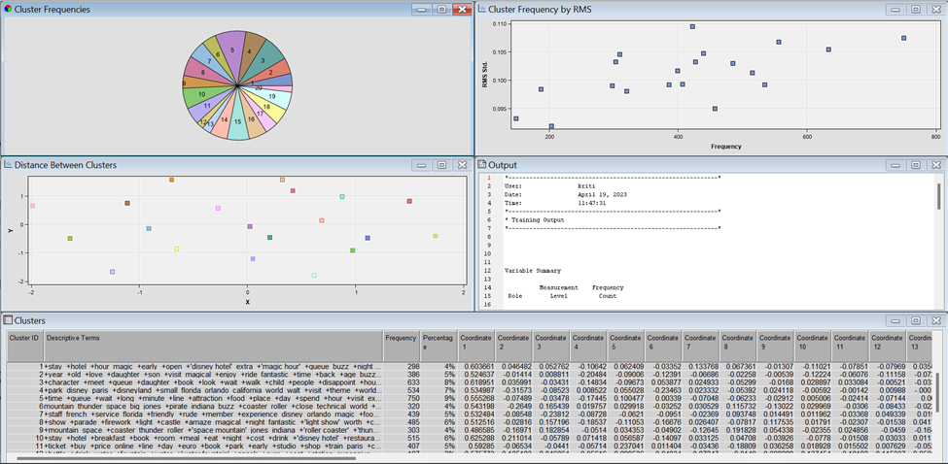

Figure 1‑4 The result of text cluster IDF

Figure 1-4 shows the result of the text cluster, it consists of a pie chart of cluster frequencies, the distance between the clusters, a table that consists of different clusters in IDF and the frequency of that clusters, and a description of each cluster, that shows the terms present in different clusters.

**Text Topic:**

After Text clusters, we added Text topics to get the topics that are present in each document. Figure 5 shows the topics that are present in the Text topic node that is connected to the text cluster of SVD 70, and the text filter that has term weight IDF.

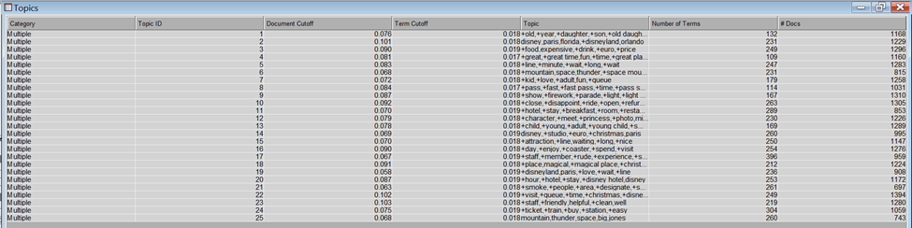

Figure 1‑5 Text Topic result

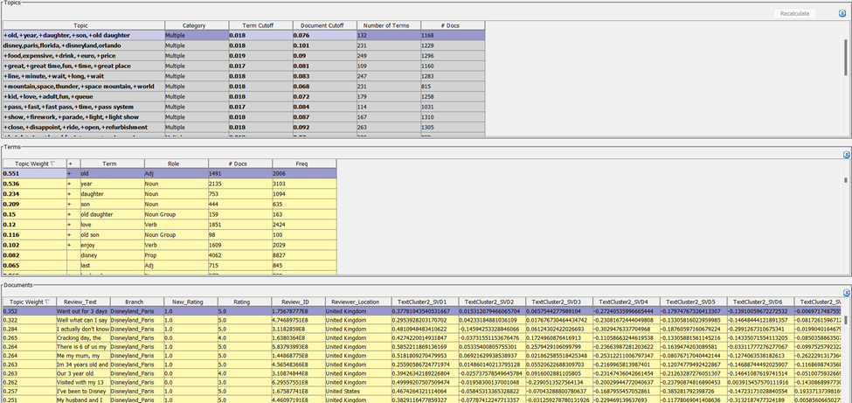

Figure 1‑6 Topic viewer

Figure 6 shows the result of Topic viewer. The first table in the figure shows the different topics present in the Text Topic, and each of these topics has multiple terms present. Like the first row in the topic has the topic that has terms old, year, daughter, son, old daughter. The second table shows each term, their term weight, frequency of that term, frequency of the documents in which this term is present.

**Model Comparison:**

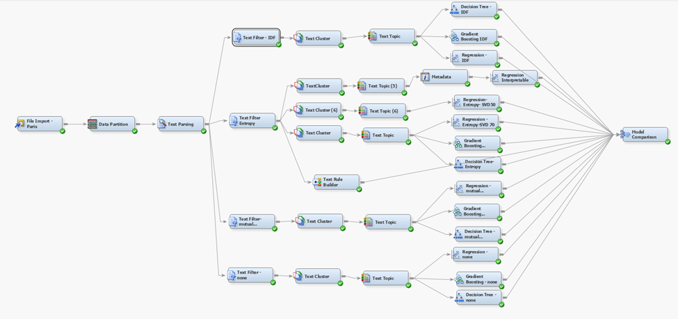

Figure 1‑7 Final Model Diagram

Figure 7 shows the final diagram, in which all models are present, for each text topic nodes there are different models are present that are regression, Gradient Boosting, Decision Tree. And finally these models are connected to the model comparison node.

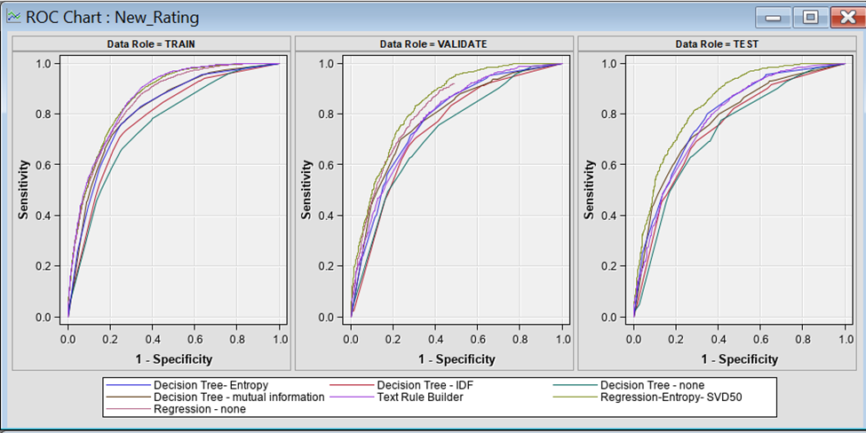

Figure 1‑8

Figure 8 shows the ROC chart of model comparison, it consist of different model and showing the ROC by different models.

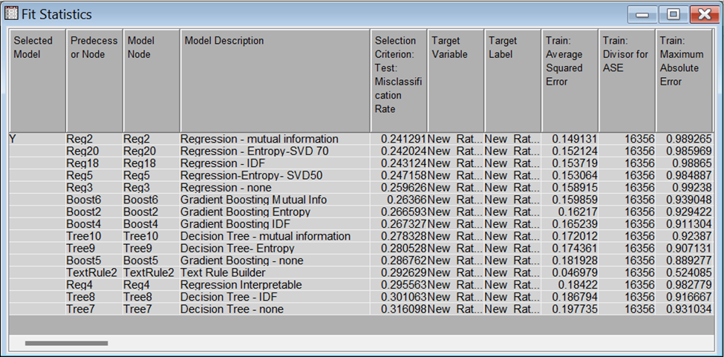

Figure 1‑9 Fit statistics and misclassification rate of all the models.

Figure 9 shows the fit statistic of different model, and Misclassification Rate of different models. The regression in which Term weight is Mutual information has least misclassification rate that is 0.241, and it is least among all other models.

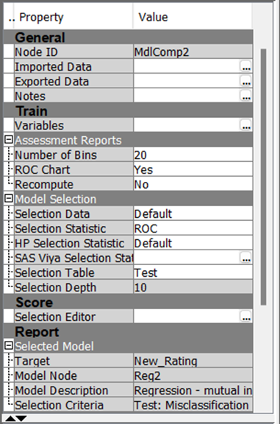

Figure 1‑10 properties panel of Model Comparison

Figure 10 shows the property panel of model comparison node, and here the Selection Criteria is changed from Misclassification node to ROC, to compare different models based on ROC.

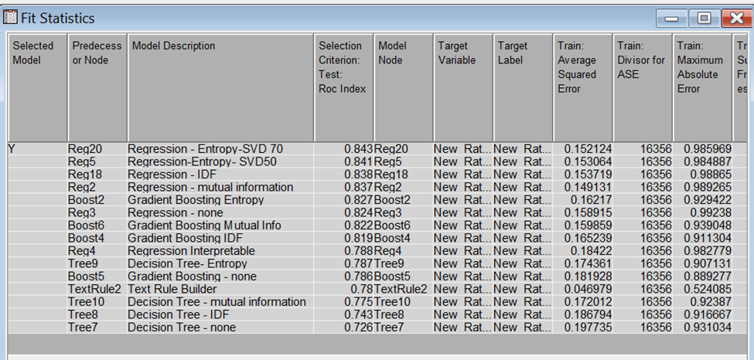

Figure 1‑11 Fit statistics based on ROC

Figure 11 shows the fit statistic of different models, based on ROC. The regression in which Term weight is Entropy and SVD 70 has the highest ROC that is 0.843 among all other models.

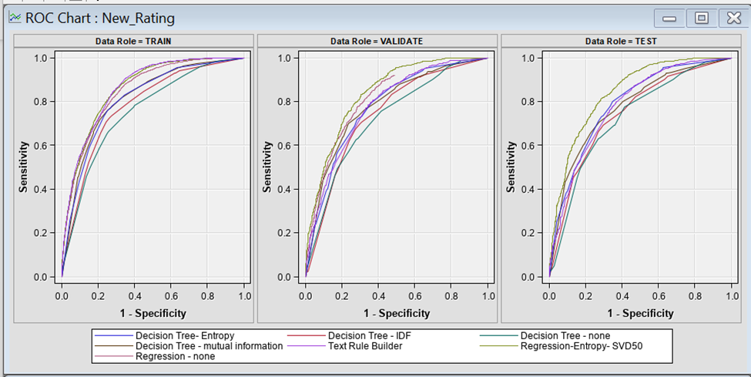

Figure 1‑12 ROC chart

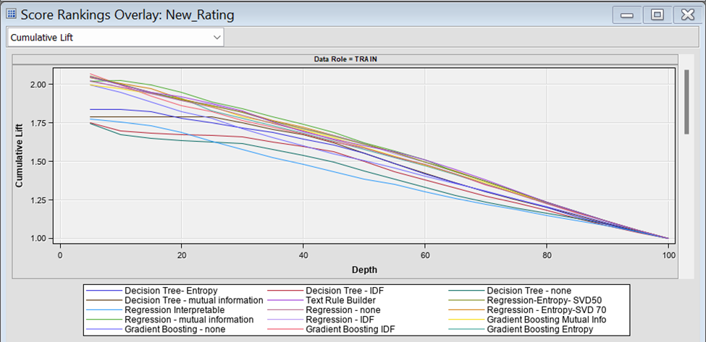

Figure 1‑13 Score Ranking Overlay

**Text Rule Builder:**

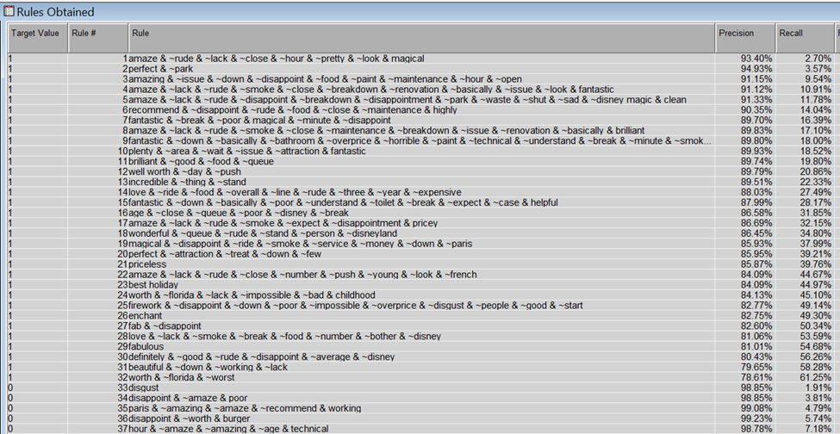

Figure 1‑14 Text Rule Builder

Figure 14 shows the output of the Text Rule Builder node. The result shows rules for the different text in the reviews that are present together, also it shows the precision and Recall of these rules. For example, in the rule “Amaze , -rude, -lack, close, -hour, -pretty, -look, magical” this mean the text rule builder node has created a rule in which amaze, close and magical are present but rude, lack, hour, pretty, and look are not present. The precision and recall of this rule are 93.4% and 2.7%.

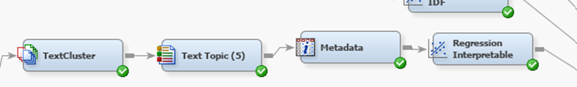

Figure 1‑15 Metadata Node

Figure 15 shows between text topic and Regression node a meta data node is connected. This node is connected to change the inputs given to the regression node. This regression is called regression Interpretable node. 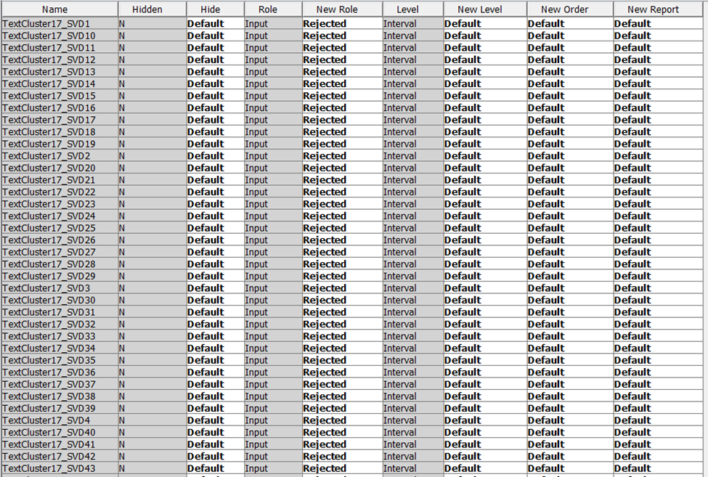

Figure 1‑16 Metadata node

For creating an interpretable Regression Figure 16 shows the metadata settings in which we rejected the TextCLuster_svd dimensions to do regression.

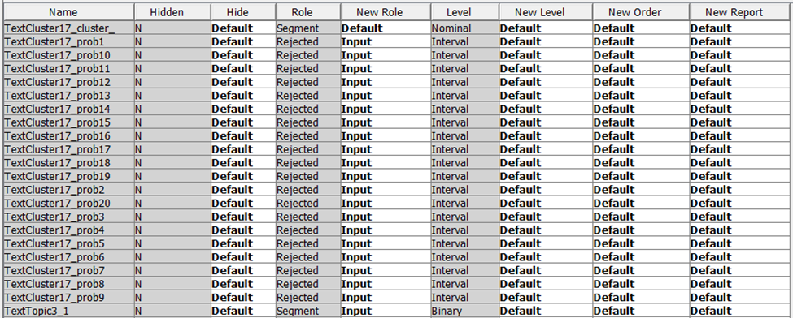

Figure 1‑17 Metadata node, Text cluster probab are set to input

The Text cluster probabilities are set to input, before it is rejected.

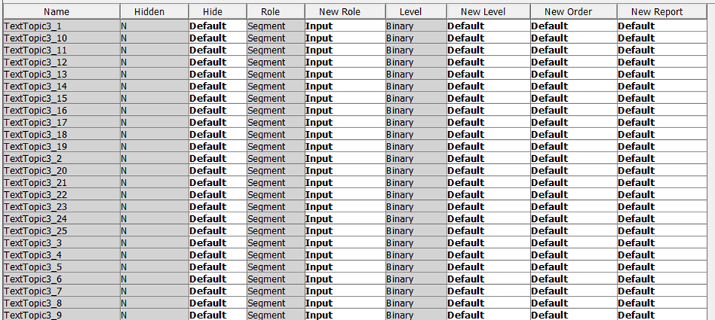

Figure 1‑18 Text topics setting changed to Input.

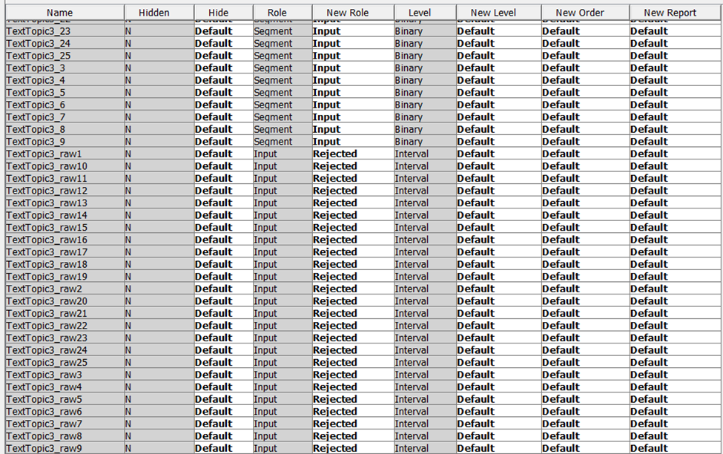

Figure 1‑19 Text topic Raw rejected

Text topic raw are rejected.

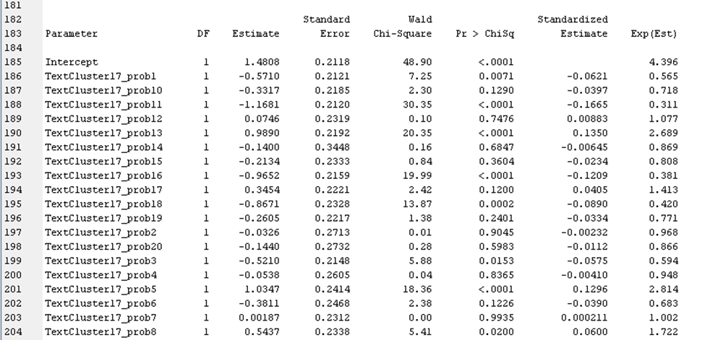

Figure 1‑20 output of Text Cluster

Fig 20 shows the output of Text cluster of regression interpretable node. It has different text cluster probabilities, and their standard estimates. For checking positive Text Clusters, that has positive standard estimate and that are statistically significant are considered as positive clusters and it shows the review is positive if one of the term from this cluster is present in the review. For checking Negative Text Clusters, that has negative standard estimate and that are statistically significant are considered as negative clusters and it shows the review is negative if one or more of the term from this cluster are present in the review.

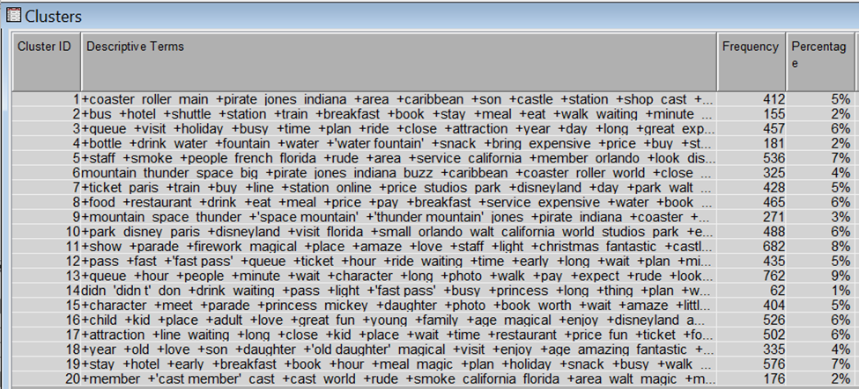

Figure 1‑21 text cluster node

Figure 21 shows the result of text cluster node of interpretable regression model. From text cluster 13 we can see that queue, hour, people, minute, wait, long photo, walk, pay, rude these can be considered as a negative cluster.

Similarly, cluster 11 has terms like show, parade, firework, magical, place, amaze, love, staff, Christmas, fantastic, castle. These are the terms that are considered as positive cluster.

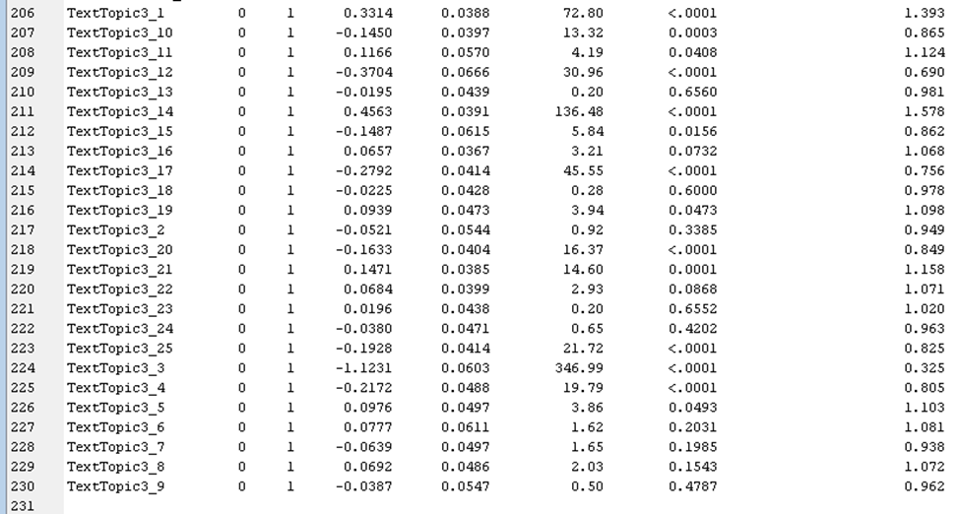

Figure 1‑22 Interpretable regression output

Fig 22 shows the interpretable regression output of Text topic. These topics have estimates and p values. And if these values are significant and estimates are high, we consider them for them for interpreting the reviews.

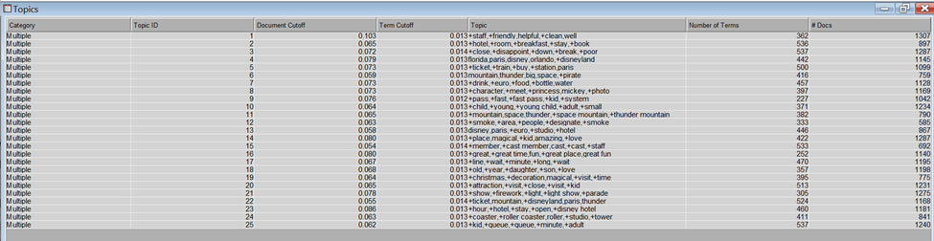

Figure 0‑23 Output of Text Topic

Text topic can be considered as negative text topic as it has the terms like line, wait, minute, long, wait. Similarly, text topic 3 is negative, as it consists of terms like close, disappoint, down, break and poor. Text topic 14 is statistically significant and has the most positive estimate as shown in figure 22, and it has terms like place, magical, kid, amazing, and love. So, it is a positive topic.

1. **Process Flow: Disneyland- Hong Kong:**

We have followed the same procedure for the Hong Kong location as well. Below are the results

Model:

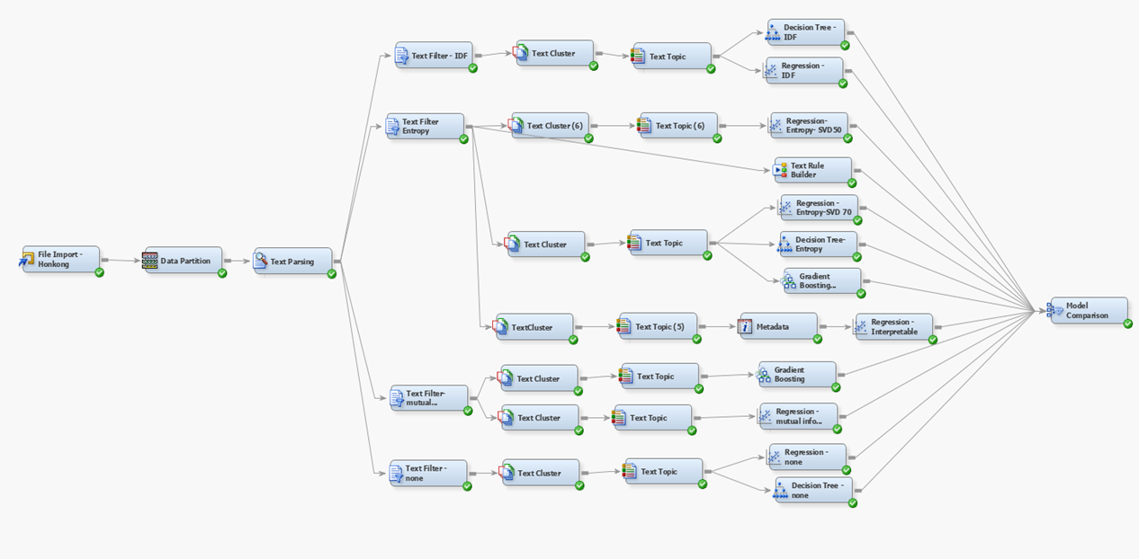

**Text Clustering:**

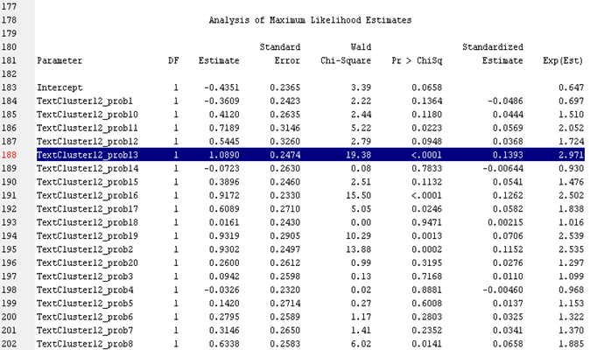

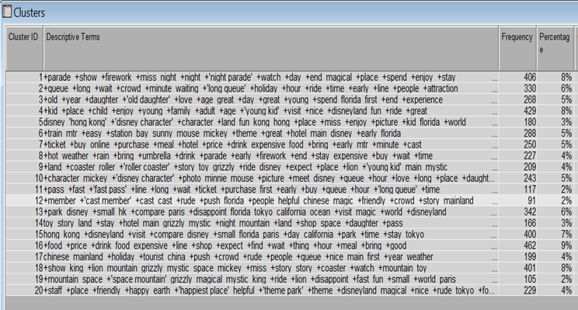

Positive clusters 1,4, 14 ​

Parade, show, firework, night, night parade, magical place, enjoy​

Kid, young, family​

Negative clusters 13, 2: ​

Park, Disney, small, disappointment, Florida, queue, long, wait, long queue

**Text Topic:**

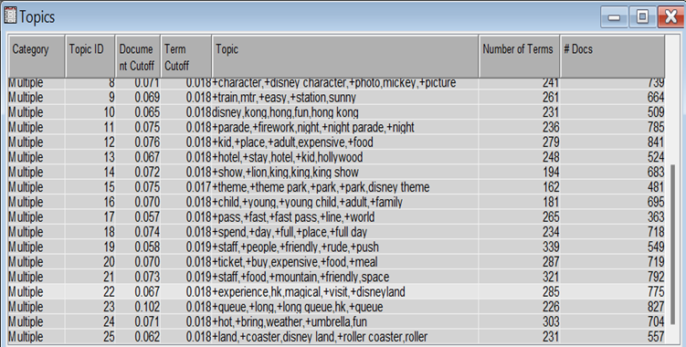

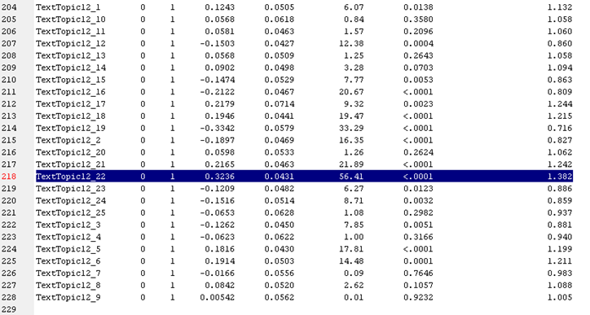

Positive Topics 22, 21, 1: ​​

Experience, magical, visit, staff, food, mountain, friendly space​

Negative Topics 19, 16, 12 :​

rude, push, child, expensive, adult

**Concept Link:**

We looked at several terms, their conceptual connections, and which terms had a close relationship to the key term. From the image below, it is clear that the terms "food" and "parade" have close associations with the various terms.

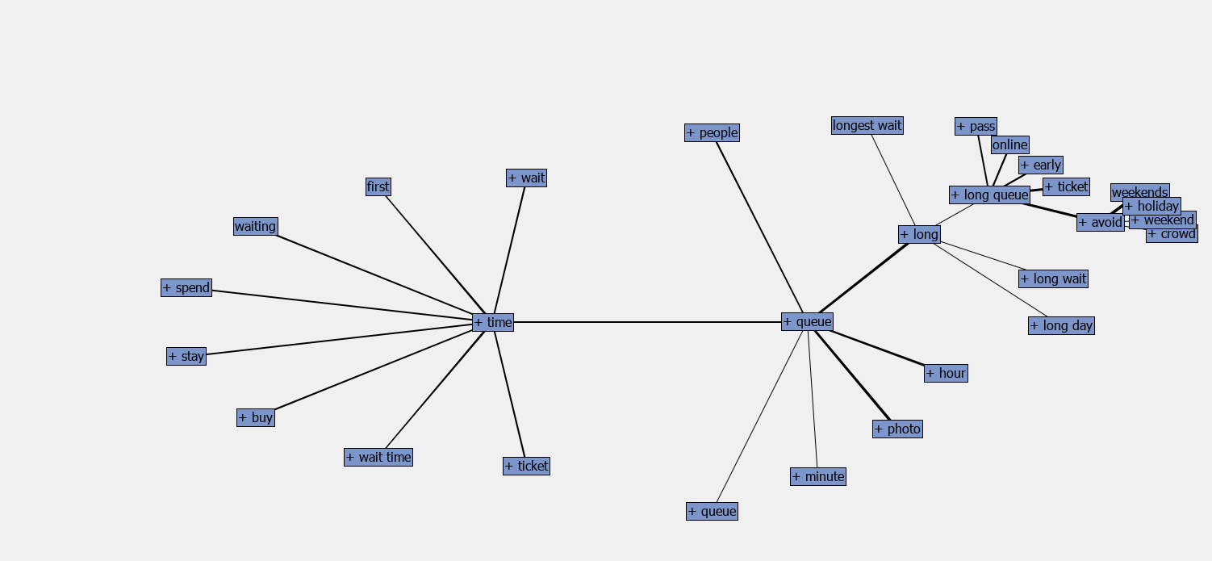

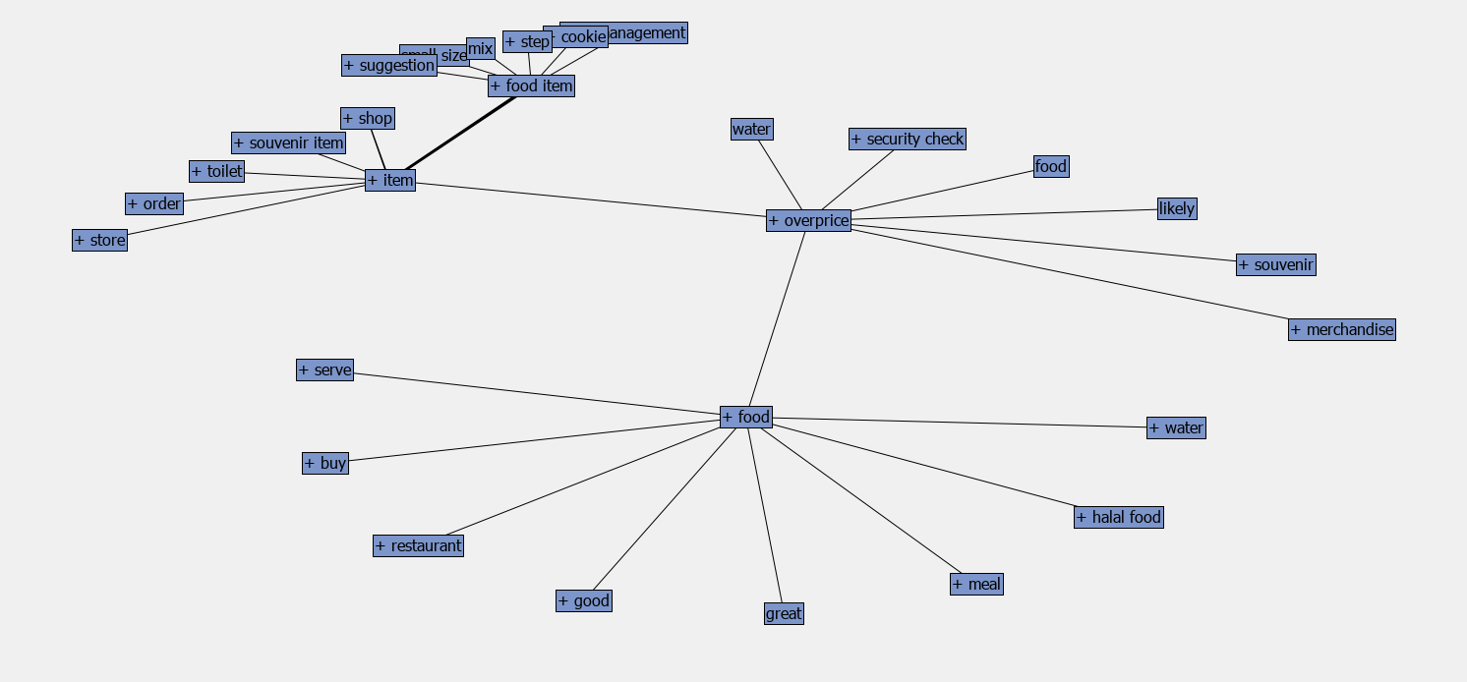

From these concept links, we can see that the word ‘food’ is strongly associated to ‘overprice’ and ‘halal food’.

The word ‘time’ is strongly associated with ‘queue’ and’long’.

**Model Comparison:**

After running the time series exploration for our data, we could see that the data has a trend and seasonality.

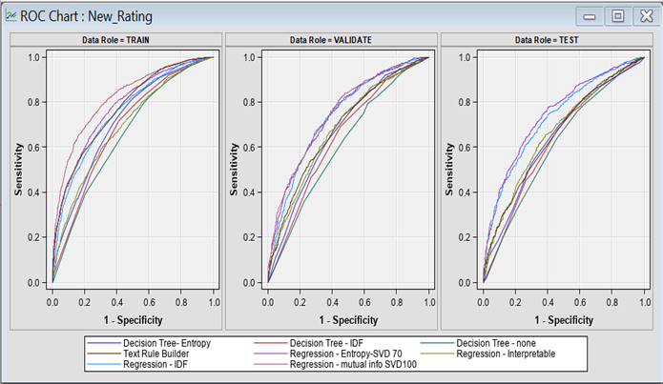

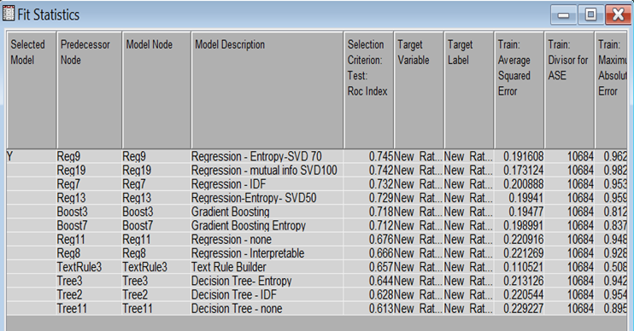

We have run different models with different svd dimensions and found that the regression model with term weight entropy and svd 70 has highest ROC i.e, 0.745. So we have proceeded with this model.

**Findings from the model:**

Here are the keywords that we found from each branch:

•DisneyLand California Branch:

Pros: Friendly Staff, Clean

Cons: Expensive

•DisneyLand Paris Branch:

Pros: Magical, Fantastic, Christmas, Parade, Staff, Castle

Cons: Queue, wait time, walk, long, smoke

•DisneyLand Hong Kong Branch:

Pros: Parade, show, firework, night, night parade, magical place,

Cons: long, wait, long queue

**Business Insights:**

Following are the business insights that we can draw from the models

* Utilize language like "Magical" and "Fantastic" in marketing materials, such as social media posts and newsletters, to create an atmosphere of awe and anticipation.
* Take advantage of the holiday season by providing exclusive promotions and discounts for Christmas-related goods or services.
* Enhance customer satisfaction and reduce wait times by implementing a queue management system that enables customers to schedule appointments or reserve a spot in line online.
* Minimize wait times by investing in extra personnel or technology to expedite the service process.
* Provide thorough instruction on customer service and communication skills to employees to promote positive behavior.